**PGBooking: An Online Booking System for Hotels and Resorts**

**In Puerto Galera**

An

Application Development Project

Presented to the Faculty of

**Mindoro State University Calapan Campus**

Masipit, Calapan City

Oriental Mindoro

In Partial Fulfillment

of the Requirements for the Degree

Bachelor of Science in Information Technology

by:

**De Guzman, Yuan Gabriel T.**

**Logatoc, Kate Angela**

**Medrano, Dominic E.**

**Rivera, Katherine B.**

**BSIT III-F1**

December 15 2023

**CHAPTER I**

**INTRODUCTION**

**Project Context**

In the dynamic landscape of travel and tourism, the demand for efficient and user-friendly booking systems is more critical than ever. PGBooking aims to address this need by introducing a specialized online booking system focused on Puerto Galera, a renowned destination in the Philippines. The travel and hospitality industry has seen a significant shift towards online platforms for booking accommodations and activities. Puerto Galera, with its picturesque landscapes and diverse attractions, is a prime location for such a system. PGBooking seeks to streamline the booking process for tourists, offering a centralized platform for reserving accommodations and recreational activities within the Puerto Galera region. As a comprehensive online booking system, PGBooking will serve as a digital repository for various services and experiences offered in Puerto Galera. The system's primary objective is to enhance the overall tourism experience by providing a one-stop solution for travelers to plan and book their entire trip seamlessly. The repository 2 will include information about hotels, resorts, and local activities available in Puerto Galera. Through open standards and user-friendly interfaces, PGBooking ensures that users can easily search, retrieve, and book services, optimizing their travel planning process. PGBooking represents a significant advancement in Puerto Galera's tourism infrastructure, providing a digital repository for a wide array of services. This project not only contributes to the efficiency of tourism management but also enhances the overall experience for tourists, thereby promoting the sustainable growth of Puerto Galera's tourism industry. There have been changes in hotel management systems as we are becoming more and more advanced. In the past bookings were made manually inside the hotel. But now it’s been digitalized and now users can just send forms to reserve a room at a hotel remotely. According to (Zhou, W., & Liu, Z. (2022), due to the improvement of people’s living standards, the traditional hotel management model has been unable to meet the needs of customers. Traditional hotel management model also has the defects of low efficiency. (Nandasiri et al., 2022) and (Ukamaka Betrand et al., 2023) both created an online hotel booking system in which customers are offered various facilities such as check-in, checkout, and entry editing, advance payments, option to cancel reservation, produce receipts, and view hotel rooms. These systems have 3 the same features as “PGBooking” does. But (Madhura et al., 2023) took it a step further by integrating AI to the system and having an AI driven chatbot and concierge, designed to deliver user friendly interface, allowing customers to ask questions. “PGBooking” has a similar function only that it is a real time chat with real hotel staff. The thing these researches have in common is that they only feature a single hotel which greatly limits it due to the fact that users will prefer to look and browse through multiple hotels to compare prices and rooms. They are also lacking in producing useful data that can be used in the future as they are only focusing on bookings of the users and only keeping records. Their websites are very simplistic in nature and users don’t have much freedom in them either as they are only allowed to book and browse in a single hotel. “PGBooking” aims to fill these gaps and help not only the hotels but also PG tourism to provide even better hotel booking experience.

**Objectives of the Study**

The main objective of this research study is to develop a Qualiteapp: An Ordering Management System For Teatime Shop Socorro. The system assists the owner in terms of queueing orders, managing products, tracking sales, and providing easy ordering to the customer which can also hinder queues.

Specifically, the objective of this study aims to:

1. Serve the best quality and interesting variety of milk tea, foods, and accompaniments.
2. Strive to give our customers a comfortable and handy web application they can access through the internet and make an order without leaving their seats.
3. Engage with our dear customers. We want to reach their voice, feedback, and complaints. Prioritizing customers and giving them the value, they need.
4. Be owner friendly. Like customers, the one who manages the store and the app will not have a hard time managing the application. It will be convenient to manage foods and drinks here in this app which will save a lot of their effort.
5. Promote the business in the industry. This app will lead the shop to another level that will make its mark in the innovative business industry. It will be one of those applications that competes with one another.

**Scope and Limitations**

The study focuses on developing a system entitled “QualiTEApp: An Ordering Management System For Teatime Shop Socorro” The scope of the study allows Teatime customers to purchase different products that the business offers through the online method. They can track their orders easily because of its real-time feature. This will help them to guarantee that their orders and requests are processed fairly and successfully. This customer application is for all the customer who wants to buy and try the products that TeaTime offers. It can be from far away or near Santol St. Zone II, Socorro, Oriental Mindoro.

**Definition of Terms**

* **Online Ordering**- the process of ordering goods and services over the Internet that allows customers to purchase products or services from a seller using a web browser or a mobile app.
* **Barkada Gimmicks**- activities that a group of friends does together for fun or to bond, such as dining out, watching movies, or going on road trips.
* **Real-time**- a term used to describe activities or processes that happen in the same amount of time that it takes for the event to occur in real life.

**CHAPTER II**

**REVIEW OF RELATED LITERATURE/SYSTEM**

This section presents the related literature both foreign and local. These help the researcher to strengthen the analysis and interpretation of the data of this study. The researchers gathered data from trusted scholarly sites to ensure the credibility and quality of the information collected.

**Foreign Literature/System**

According to Aini, Q., and Putri, D. M. (2019), in today’s world, technology is the driving force behind most businesses and companies. The use of technology can support the success of a store or company, giving them a competitive edge over its competitors. With the right technology, shops and companies can increase their sales and revenues while reducing their expenses. Not only is the use of technology integration to a company’s success, but the type of technology used is also important. Companies must be sure to use the latest, most reliable, and most secure technology in order to keep up with their competitors. This means having the latest gadgets and software, and ensuring that their websites and applications are up-to-date and secure. Additionally, companies must ensure that their technology is user-friendly and easy to use. This is especially important for customer-facing technology, such as a website or mobile application. If customers find the technology difficult to use, they will be less likely to use it or recommend it to others. This can lead to a decrease in sales and a decrease in customer loyalty.

Moreover, Aini Q. et al. (2020) stated that the integration of information technology into our daily lives is undeniable. It has permeated almost every aspect of our lives, from the way we communicate to the way we manage our finances. Information technology has become an integral part of our society, and it is no longer possible to separate business and economic activity from information technology. Information technology is used in a variety of different ways in the business and economic world. Businesses can use it to streamline operations, improve customer service, and increase efficiency. It can also be used to store and analyze large amounts of data, allowing businesses to make better decisions. Additionally, information technology can be used to create new products and services, and even to automate processes. In the economic world, information technology can be used to facilitate transactions, improve financial security, and track market data. It can also be used to create new financial instruments, such as cryptocurrency and digital assets. Additionally, information technology can be used to monitor economic trends, allowing for more efficient investment decisions.

Furthermore, R. Tamilarasi and N. Elamathi (2018) discussed the internet about how it revolutionized the way we do business in a variety of ways. One of the most significant impacts the internet has had is on the ability of businesses to access customers from all around the world. Prior to the internet, businesses were limited by geographical boundaries and had to rely on expensive and inefficient methods of reaching potential customers. However, with the emergence of the internet, businesses can now target customers from any location, allowing them to access a much larger and more diverse customer base. In addition to providing businesses with access to customers beyond geographic boundaries, the internet has also made it easier for businesses to maintain their presence in the market. Social media platforms such as Facebook, Twitter, and LinkedIn have become essential tools for businesses to stay connected with their customers and build relationships with them. These platforms allow businesses to post regular updates, interact with customers in real-time, and advertise their products and services.

Huseynov, F. and Özkan Yıldırım, S. (2019) stated that the rise of e-commerce has drastically changed the way businesses and consumers shop. This is particularly true for the retail industry where online shopping has become the norm for many consumers. E-commerce has opened up a whole new world of opportunities for businesses to effectively sell their products and services. By providing businesses with a platform to reach out to customers all over the world, it has revolutionized the way people shop. The growth of e-commerce has created an incredibly competitive landscape. With a variety of e-commerce portals available, it is essential that businesses choose the right one for their business. The right e-commerce portal should be able to facilitate the sale of products and services, as well as manage customer data. It should also provide an easy-to-use interface, comprehensive product information, and secure payment processing.

Additionally, Alalwan, A. A. (2020), added that the restaurant sector has been revolutionized by the introduction of Mobile Food Ordering Apps (MFOAs). These apps have been widely embraced as an innovative way to reach customers and provide them with the highest quality services. MFOAs have drastically improved the customer experience by streamlining the entire ordering and checkout process. Customers can now browse a restaurant’s menu, customize their order and pay for it in a matter of minutes. Moreover, customers can take advantage of discounts, promotions, and other offers that are often available through MFOAs.

**Local Literature/System**

According to Lim, S., & Noroña, M. I. (2021), online food delivery service has revolutionized the way people order food. With the rise of the O2O e-commerce industry, the online food delivery (OFD) App has made it easier than ever to order food from various restaurants with just one click. This has been a major boon to those who do not have the time or energy to venture out and make the purchase in person. The convenience of online food delivery has been especially beneficial during the pandemic. With health and safety precautions in place, it has become increasingly difficult to go out and eat in restaurants. Moreover, with the lockdown in place, many people were forced to stay home and were unable to purchase food from stores. The OFD App came to the rescue here as it allowed people to order food from the safety and comfort of their own homes. In addition to the convenience of ordering food online, the OFD App has also enabled customers to access a wider selection of food from different restaurants. This has enabled customers to explore different cuisines and cultures without having to leave their homes.

Furthermore, Gamilla, C. O. (2021) discussed the pandemic of 2020 changed the way people view the world and the way they live their lives. People are now relying more on technology to get their needs and want to be fulfilled, and one of the areas experiencing the most significant growth is online food delivery services. Last year, the market for online food delivery services tripled its revenue, and Mi Company, one of the leading food delivery companies in the Asia Pacific region, reported a net revenue increase of 70%. The growth in the food delivery industry is largely attributed to the pandemic. People had to stay at home and limit their physical interactions, which led them to turn to eCommerce technology for their purchases - including food. The convenience of ordering food online and having it delivered to their doorstep without risking their health and safety was a great incentive for many people. As the industry continues to grow, technology innovation will play an essential role in sustaining the food delivery industry. Companies need to keep up with the growing demand of consumers and adapt to the changing trends.

According to Doctora, A. L. S., (2020) the modern world has seen the emergence of fast-food restaurants as a popular and convenient option for consumers. Fast food restaurants offer quick service with no need for customers to prepare their own food. In recent years, the convenience of fast food has been taken to the next level with the introduction of online delivery systems. These systems allow customers to order fast food without having to leave the comfort of their own homes. The analytical hierarchy process (AHP) has been used to compare the online delivery systems of three popular fast-food chains: Jollibee, McDonald’s, and KFC. By utilizing the AHP, researchers have identified six criteria to consider when evaluating the online delivery systems of these three companies. These criteria include convenience, flexibility, accuracy, reliability, user-friendliness, and quality.

The internet has revolutionized how people shop and purchase goods and services. With the Philippines having a significant share of its population going online, online shopping has become an emerging trend. Over the past few years, the number of online shopping transactions has increased exponentially, making it increasingly important to understand the barriers that hinder the market. While there is a great deal of current literature that considers buyers' perspectives, there is limited insight into the sellers' perceptions. In order to gain a holistic view of the barriers to online shopping, it is necessary to understand the sellers' point of view. To this end, a study was conducted to identify the barriers of online shopping and their interrelationships, both from the sellers' and buyers' perspectives, using interpretive structural modeling and MICMAC analysis. (Guerrero, V. G. G., 2023)

Additionally, Castillo, A. M. M., (2021) added that digitalization is quickly transforming the way customers interact with businesses and services, yet the drive-through experience has remained largely unchanged since its introduction in 1947. A recent study conducted in fast-food restaurants offering drive-through services in Metro Manila, Philippines, revealed that the average transaction time was 6.27 minutes. The researchers also discovered that out of 100 customers, 57 experienced long queues and delays, while 43 did not. The findings of this study demonstrate that there is a need for improvement in the drive-through experience. Despite the rise of digitalization, the drive-through has not been able to keep up with the changing expectations of customers. This is likely due to the lack of investment in new technologies and processes that could improve the drive-through experience.

**REQUIREMENTS SPECIFICATION**

Functional Requirements define the functions and processes that the software must perform in order to meet the needs of its users. It provides a detailed description of the behavior of the system in response to inputs, outputs, and expected results. This level of detail is necessary to ensure that the system has a strong foundation for its performance.

**Hardware Requirements**

Hardware Requirements refer to the representation of the hardware used by the system. Table 1 below presents the hardware requirements to be used by the project.

|  |  |  |  |  |
| --- | --- | --- | --- | --- |
| **Hardware** | **Functions** | **Specifications** | | **Unit** |
| **Minimum** | **Recommended** |
| Computer/  Processor | It is used to handle the complex tasks associated with creating a strong, secure, and reliable system to provide us with the computing power we need to ensure our system is optimized for performance and reliability. | Intel  (R) Core  (TM) i3-7020U CPU | i3 and above of version | 1 |
| RAM | It acts as a temporary memory storage for the system. It enables the computer to quickly access the website's data and process it efficiently, providing a faster and smoother browsing experience. | 4GB | 6GB | 2 |
| Android Smartphone | It is used if the customer wants to access the system conveniently and for easy order the products they want. |  |  | 3 |

**Table 1: Software Requirements**

**Software Requirements**

Software Specifications refer to the representation of the software used by the system. Table 2 below presents the software specifications to be used by the project.

|  |  |
| --- | --- |
| Software Used | Description |
| Operating System | The researchers chose the Windows 10 operating system because it will suit and can support the system. |
| XAMPP | The Xampp provides a graphical interface for SQL which is the phpMyAdmin that helps to maintain data in a relational database. |
| Visual Studio Code | Visual Studio Code is a code editor that supports development operations like debugging, task running, and version control. |
| CodeIgniter 4 | Codeigniter 4 is the framework being employed for the creation of the system. It is a set of tools for constructing websites using PHP. |
| Bootstrap, HTML and CSS | These are the programming languages needed to create a visually appealing and user-friendly graphical interface for front-end coding. |

**Table 2: Software Requirements**

**Functional Requirements**

This part enumerates the operations and activities that the system must perform. Table 3 represents the descriptions of data requirements, process requirements, and output requirements.

|  |  |
| --- | --- |
| **ID NO** | **Requirement Description** |
| **FR1** | **Data Requirements** |
| **Admin Account** | |
| 1.1 | The admin must input a username and password to access the system. |
| 1.2 | The admin can send notifications to the client with all transactions. |
| 1.3 | The admin can be able to add/modify/view products as well as they can see also all transactions, such as product orders, delivery, and voided transactions |
| 1.4 | The admin must provide a menu management |
| **User Account** | |
| 1.5 | The user must input a username and password to access the webpage |
| 1.6 | The user can add to the cart all the products they want to buy |
| 1.7 | The user can reserve their table slots |
| 1.8 | The user can give suggestions through feedback |
| **FR2** | **Process Requirements** |
| **Admin Account** | |
| 1.9 | The system must accept the registration of the new user. |
| 2.0 | The system must accept all the orders from customers and process them immediately. |
| 2.1 | The system must send notifications email to the client with all transactions. |
| 2.2 | The system must send a confirmation email whenever an order is placed. |
| **User Account** | |
| 2.3 | The system must receive an email notification of the previous transaction. |
| 2.4 | The system can view and track their orders in real-time. |
| **FR3** | **Output Requirements** |
| **Admin Account** | |
| 2.5 | The system must be able to create an inventory management |
| 2.6 | The system must provide Sales Analytics. |
|  |  |
| **User Account** | |
| 2.7 | The system must print all history transaction |
|  |  |

**Table 3: Functional Requirements**

**Non-Functional Requirements**

These are requirements that pertain to behavior properties that a system must have. It defines how a system is supposed to be or its system properties. It contains the following:

**Operational Requirement**

Table 4 represents the requirement description that will specify the operating environment(s) in which the system must perform and how these might change over time.

|  |  |
| --- | --- |
| ID No. | Requirement Description |
| 1.1 | The system is compatible with any operating system |

**Table 4: Operational Requirement**

**Performance Requirement**

Table 4 represents the requirement description that will emphasize the response time, capacity, and reliability of the system.

|  |  |
| --- | --- |
| ID No. | Requirement Description |
| 1.2 | Each web page must load within 2 seconds |
| 1.3 | The user can track their orders 98% of the time without failure. |
| 1.4 | Any user can order and buy the products in the system. |

**Table 5: Performance Requirement**

**Security Requirement**

Table 5 represents the requirement description that will address issues with security, such as who has access to the system's data and must have the ability to protect data from disruption or data loss.

|  |  |
| --- | --- |
| ID No. | Requirement Description |
| 1.5 | The user’s information must be encrypted |
| 1.6 | Only the admin can view the inventory and sales statistics |
| 1.7 | The user’s must be logged in before they can order or can access the homepage of QualiTEApp. |

**Table 6: Security Requirement**

**Chapter III**

**DESIGN AND DEVELOPMENT METHODOLOGIES**

**System Design**

The project developers created a comprehensive plan in order to implement the QualiTEApp system. This way customers can use the QualiTEApp Shop Socorro to place orders and gain easier access to information. Additionally, transactions will be processed more quickly and efficiently. This system is hosted on a website which requires an internet connection for the administrator and customers to use it. Customers who have already registered can access the system through the website.

**Database Design**

The design of the database that includes the many entities on the QualiTEApp is an important part of application development. This gives users information about existing organizations and outlines how to utilize the application.

This shows the tables, including the fields utilized, similar data types, and a description. It gathered, organized, and validated the meaning of specified data phrases. This also demonstrates the link between the two entities.

For the database design, the developers use MySQL for the RDBMS. MySQL allows us to have a relation for tables that needs to be connected to each other. The database design will be for QualiTEApp.

|  |  |  |  |  |
| --- | --- | --- | --- | --- |
| **Field Name** | **Data Type** | **Size** | **Default** | **Description** |
| id | int | 11 | Not Null | User ID |
| name | Text |  | Not Null | User Name |
| password | Text |  | Not Null | User Password |
| email | Text |  | Not Null | User Email |
| usertype | varchar | 11 | Not Null | User Usertype |
| status | varchar | 20 | Not Null | User Status |
| created_at | datetime |  | Current_timestamp | Time Created |
| Updated_at | datetime |  | Current_timestamp | Time Updated |

**Table 7. Fields for User**

Table 7 above contains the field name, data type, size, default, and description of the field in the User table. Here, the id is the Primary Key (PK).

|  |  |  |  |  |
| --- | --- | --- | --- | --- |
| **Field name** | **Data type** | **Size** | **Default** | **Description** |
| id | int | 11 | Not Null | Products ID |
| name | text |  | Not Null | Products Name |
| description | text |  | Not Null | Products Description |
| price | float |  | Not Null | Products Price |
| quantity | int | 11 | Not Null | Products Quantity |
| image | text |  | Not Null | Products Image |
| category | varchar | 30 | Not Null | Products Category |
| created_at | datetime |  | current_timestamp | Time Created |
| Updated_at | datetime |  | current_timestamp | Time Updated |

**Table 8. Fields for Products**

Table 8 above contains the field name, data type, size, default and description of the field in the Products table. Here, the id is the Primary Key (PK).

|  |  |  |  |  |
| --- | --- | --- | --- | --- |
| **Field Name** | **Data Type** | **Size** | **Default** | **Description** |
| id | int | 11 | Not Null | Cart id |
| userid | int | 11 | Not Null | User id (FK) |
| menuid | int | 11 | Not Null | Menu id (FK) |
| order_count | int | 11 | Not Null | Cart order_count |
| size | varchar | 20 | Not Null | Cart Size |
| total | float |  | Not Null | Cart Total |

**Table 9. Fields of Cart**

Table 9 above contains the field name, data type, size, default and description of the field in the Cart table. Here, the id is the Primary Key (PK), while the userid and menuid is the Foreign Key (FK).

|  |  |  |  |  |
| --- | --- | --- | --- | --- |
| **Field Name** | **Data Type** | **Size** | **Default** | **Description** |
| id | Int | 11 | Not Null | Menu ID |
| name | Text |  | Not Null | Menu Name |
| prod_name | Text |  | Not Null | Menu Prod_name |
| description | Varchar | 50 | None | Menu Description |
| category | Varchar | 30 | None | Menu Category |
| prices | Float |  | None | Menu Prices |
| discount | Int | 11 | None | Menu Discount |
| image | Varchar | 30 | None | Menu Image |
| stocks | Int | 11 | None | Menu Stocks |
| status | Varchar | 30 | None | Menu Status |

**Table 10. Fields of Menu**

Table 10 above contains the field name, data type, size, default and description of the field in the Menu table. Here, the id is the Primary Key (PK).

**Architectural Diagram/ Block Diagram**

In this section, system architecture was designed to define the flow and behavior of the system’s functionalities to execute its high-quality performance. This covers the formal illustration and description of the project structure.



**Internet**

**Admin**

**Customer Login**

**QualiTEApp Application**

**Transactions**

**Figure 1. System Architecture of QualiTEApp Website**

Figure 1 shows the system architecture of the development of the QualiTEApp Application. It displays the flow and how the system work. The researchers show that the internet is needed in order to access the website of both client and admin to proceed with the intended transactions.

**Data Flow Diagram Level 0**

This section shows the Data Flow Diagram Level 0 which is commonly known as an exploded view of the context diagram that shows the detailed process of how the project works.

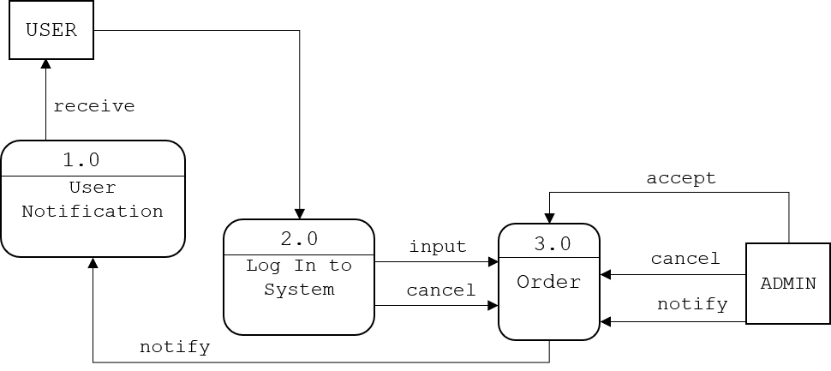**Figure 2. Data Flow Diagram Level 0**

Figure 2 diagram 0 shows the sequence of the system on the admin side. The system indicates all the functions that the admin can do, It includes user notification, logging in to the system, and order. Admin can select any of the following bases on how they need it and use the system.

**UML Use-case Diagram**

In this section, the use case diagram summarizes the high-level functions and a graphic representation that depicts the relationship between the system, admin, and users, it is how the system works within interactions of the actors. The diagram will help the researchers to identify and 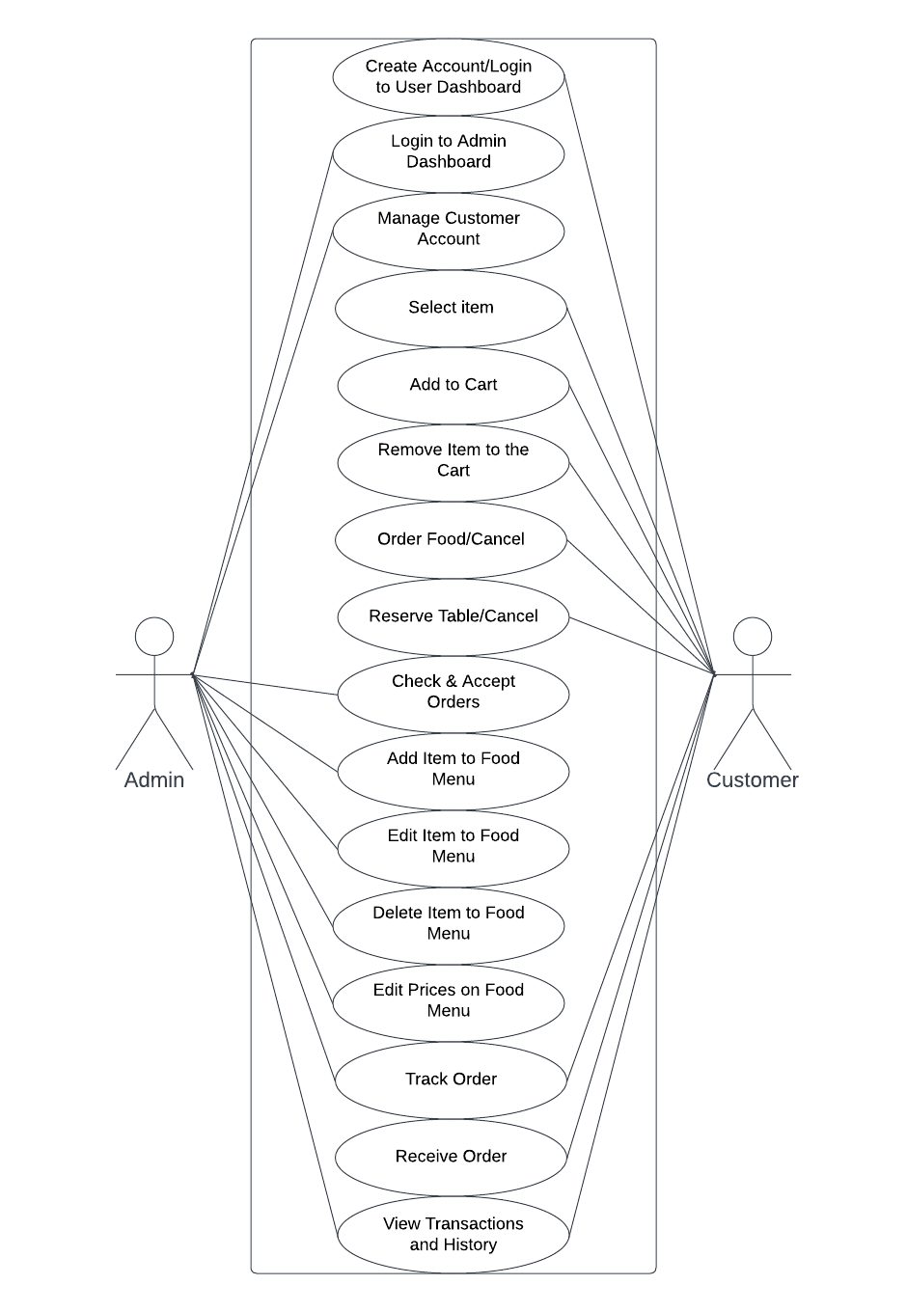organize the functionality of the entire project.

**Figure 3. UML Use-case Diagram**

Figure 3 shows the roles of the Administrator and the customer to be executed in the whole process of the system.

**Sample Mock-up**

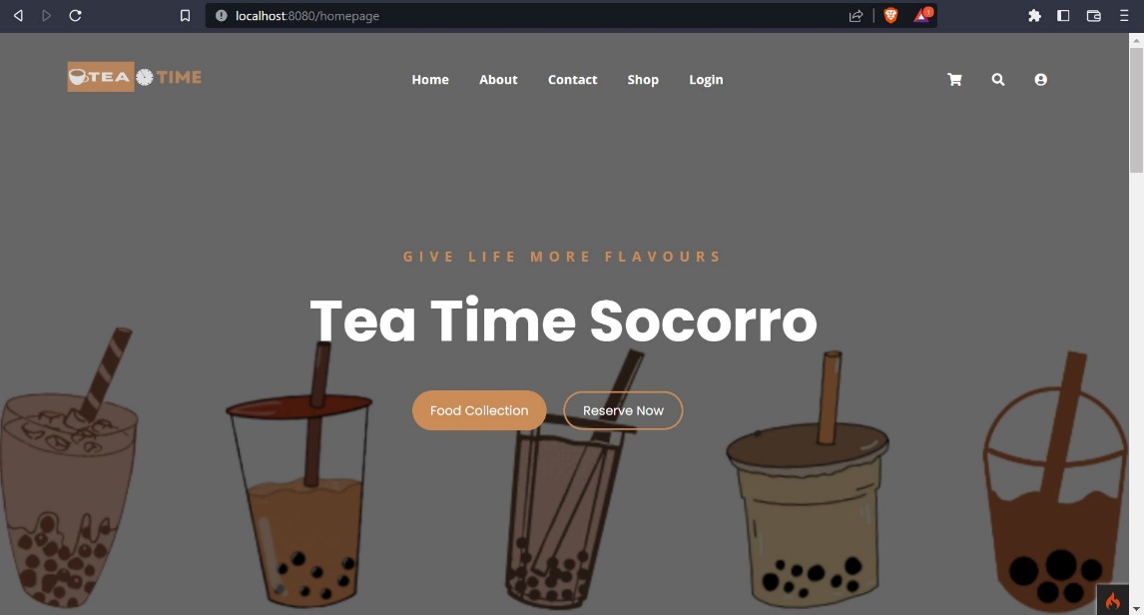A sample mock-up is a visual representation of a website after it is built. It consists of visuals that show how the website should look and its function. It is used to refine the design, identify potential problems, and ensure that the system meets the user's needs and expectations. Below are the system users and admin interface.

**Figure 4. User Interface**

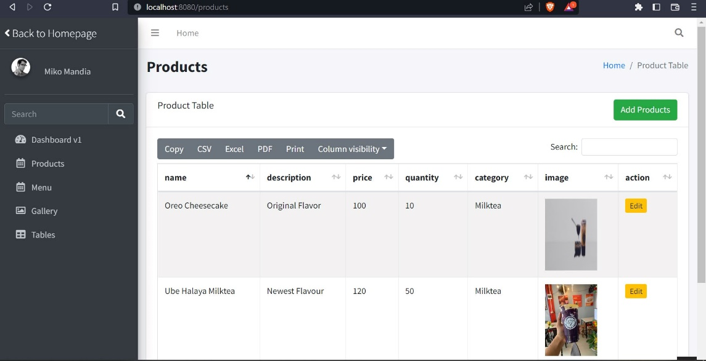

**Figure 5. Admin Interface**

**Development Method**

The “QualiTEApp: An Ordering Management System For Teatime Shop Socorro” will employ the System Development Life Cycle (SDLC) to ensure the production of an efficient and high-quality system. This project will use an Iterative and Incremental Model, which allows for improvements to be made throughout the development process. The SDLC is divided into four phases: collecting requirements, design and development, testing, and implementation. These steps will be followed in order to create a successful system.

**Requirements Gathering**

**Testing**

**Implementation**

**Design & Development**

**Testing**

**Implementation**

**Design & Development**

Build 1

Build 2

**Testing**

**Implementation**

**Design & Development**

Build 3

**Planning**

**Maintenance**

**Figure 6. SDLC Iterative and Incremental Model**

The research followed the following phase.

1. **Planning.** In this phase, researchers conduct interviews and observations according to the problem that needed to be resolved. Researchers developed the objectives and plans of the project that serves as the foundation to produce the desired output of the system at the end of the study.
2. **Requirements Gathering.** In this phase, researchers will gather more information and data requirements needed for the development of the system. Also, determine the functional and non-functional requirements of the project.
3. **Design.** During this phase, researchers will begin to design the hardware and software of the system according to the requirements of the users. The developer will thoroughly plan and implement trial and error to be able to meet the desired output of the user interface.
4. **Development.** During this phase, researchers will start the coding process for the functionality of the system through Visual Studio Text Editor Application and PhpMyAdmin as administrator tool for the database, wherein database will serve as data storage of the system and CodeIgniter 4 as the framework of the proposed system.
5. **Testing.** In this phase, researchers will execute the pre-deployment of the system for trial and error just to see if the device is properly functioning.
6. **Implementation.** In this phase, researchers will create the iteration of the project after the testing process in order to analyze and improve the design and functionality which needs more improvements to meet the project objectives.
7. **Maintenance.** In this phase, researchers must maintain the functionality of the system during deployment to maintain its performance. Also, researchers will determine and fix the errors that may occur over a period of time.

**Gantt Chart**

In this section, Gantt Chart is presented to show the plans and schedules of the project timeline. All the development stages up to the completion of the project were documented in this chart. This helps the researchers to know the deadlines needed to accomplish and show breakthroughs in various tasks.

**Table 11. Gantt Chart**

|  |  |  |  |  |  |  |  |  |  |  |  |  |  |  |  |  |  |  |  |  |
| --- | --- | --- | --- | --- | --- | --- | --- | --- | --- | --- | --- | --- | --- | --- | --- | --- | --- | --- | --- | --- |
| **Task Name** | **Task Date** | | | | | | | | | | | | | | | | | | | |
| Oct | | | | Nov | | | | Dec | | | | Jan | | | | Feb | | | |
| Week 1 | Week 2 | Week 3 | Week 4 | Week 1 | Week 2 | Week 3 | Week 4 | Week 1 | Week 2 | Week 3 | Week 4 | Week 1 | Week 2 | Week 3 | Week 4 | Week 1 | Week 2 | Week 3 | Week 4 |
| **1.Planning** |  |  |  |  |  |  |  |  |  |  |  |  |  |  |  |  |  |  |  |  |
| 1.1 Conduct an interview |  |  |  |  |  |  |  |  |  |  |  |  |  |  |  |  |  |  |  |  |
| 1.2 Define project objectives |  |  |  |  |  |  |  |  |  |  |  |  |  |  |  |  |  |  |  |  |
| 1.3 Define project plan |  |  |  |  |  |  |  |  |  |  |  |  |  |  |  |  |  |  |  |  |
| 1.4 Approval of project plan |  |  |  |  |  |  |  |  |  |  |  |  |  |  |  |  |  |  |  |  |
| **2.Requirements Gathering** |  |  |  |  |  |  |  |  |  |  |  |  |  |  |  |  |  |  |  |  |
| 2.1 Data Collection |  |  |  |  |  |  |  |  |  |  |  |  |  |  |  |  |  |  |  |  |
| 2.2 Functional |  |  |  |  |  |  |  |  |  |  |  |  |  |  |  |  |  |  |  |  |
| 2.3 Non-Functional |  |  |  |  |  |  |  |  |  |  |  |  |  |  |  |  |  |  |  |  |
| **3.Design** |  |  |  |  |  |  |  |  |  |  |  |  |  |  |  |  |  |  |  |  |
| 3.1 Frontend software design |  |  |  |  |  |  |  |  |  |  |  |  |  |  |  |  |  |  |  |  |
| **4.Development** |  |  |  |  |  |  |  |  |  |  |  |  |  |  |  |  |  |  |  |  |
| 4.1 Back-end coding |  |  |  |  |  |  |  |  |  |  |  |  |  |  |  |  |  |  |  |  |
| **5.Testing** |  |  |  |  |  |  |  |  |  |  |  |  |  |  |  |  |  |  |  |  |
| 5.1 Functionality testing |  |  |  |  |  |  |  |  |  |  |  |  |  |  |  |  |  |  |  |  |
| 5.2 User interface testing |  |  |  |  |  |  |  |  |  |  |  |  |  |  |  |  |  |  |  |  |
| **6.Implementation** |  |  |  |  |  |  |  |  |  |  |  |  |  |  |  |  |  |  |  |  |
| **7.Maintenance** |  |  |  |  |  |  |  |  |  |  |  |  |  |  |  |  |  |  |  |  |
| 7.1 Project monitoring |  |  |  |  |  |  |  |  |  |  |  |  |  |  |  |  |  |  |  |  |
| 7.2 Resolve system errors |  |  |  |  |  |  |  |  |  |  |  |  |  |  |  |  |  |  |  |  |

**Legend:** - Completed/ Done

Table 11 shows the whole process of developing QualiTEApp. It displayed the various tasks and marks as completed oats certain date. Researchers will be kept informed of the progress of the development which will help them not to miss out on steps and differentiate tasks from the amount of time took to complete them.

**Testing and Evaluation**

This section is referring to the testing and evaluation phase of the software development process. During this phase, developers are required to conduct tests on their system to determine its capabilities and limitations. This will allow them to identify any issues or potential problems prior to the production and deployment stages. The tests should include all the requirements outlined in the Requirements Phase, such as design, performance, supportability, etc. The results of these tests will be evaluated to assess the progress of the system and ensure it meets the requirements of the project. The developers considered the following:

1. **Unit Testing**- a type of software testing where individual units or components of a software system are tested. This type of testing is usually done by the developers, as it requires detailed knowledge of the internal structure of the system. Unit Testing is designed to test individual functions, modules, and features of the system, to ensure that they all behave as expected
2. **Component Testing**- involves testing the individual components of the system (modules, classes, objects, and programs) in isolation, without integrating them with other components. This helps to identify any defects or bugs in the individual components before they are integrated into the system. It also helps to identify any unexpected interactions or dependencies between components that could cause problems or errors in the system.
3. **System Testing**- a type of software testing that evaluates the entire system or application and its components to verify that all individual modules are working properly and that data is transferred accurately between modules and the entire system. System testing is meant to ensure that the system meets its requirements, performs as expected, and functions correctly in its intended environment. It is an overall test of the system and its components, and it is typically done after unit and integration testing.
4. **Unit Acceptance Testing**- a process to validate if the unit (which could be a software, product, or service) meets the requirements of the end-users and clients. During unit acceptance testing, end-users and clients interact with the unit and provide feedback on its features, usability, and performance. Based on their feedback, they either accept or reject the unit. It is an important step in the development process as it ensures that the unit meets the expectations of the use

**REFERENCES**

Aini, Q., & Putri, D. M. (2019). Effectiveness of Installment Payment Management Using Recurring Scheduling to Cashier Performance. Aptisi Transactions On Management, 3(1), 13-21.

Aini, Q., Dhaniarti, I., & Khoirunisa, A. (2019). Effects of ILearning Media on Student Learning Motivation. Aptisi Transactions On Management, 3(1), 1-12.

R. Tamilarasi and N. Elamathi, “E-Commerce- BusinessTechnology- Society,” vol. 4, pp. 33–41, 2018.

Huseynov, F., & Özkan Yıldırım, S. (2019). Online Consumer Typologies and Their Shopping Behaviors in B2C E-Commerce Platforms. SAGE Open, 9(2).

Alalwan, A. A. (2020). Mobile food ordering apps: An empirical study of the factors affecting customer e-satisfaction and continued intention to reuse. International Journal of Information Management, 50, 28-44.

Lim, S., & Noroña, M. I. A Study of Stakeholders Perception of Factors Affecting Online Food Delivery Service Industry in the Philippines.

Gamilla, C. O. (2021). Revenue boom of Online Food delivery industry amidst Pandemic: Evidence from the Philippines. International Journal of Progressive Research in Science and Engineering, 2(4), 24-26.

Doctora, A. L. S., Perez, W. D. D., Sanchez, F. N. A., Vasquez, A. B., & Borres, R. D. Application of Analytical Hierarchy Process in the Comparison of Jollibee, McDonald’s, and KFC In-House Online Delivery System.

Guerrero, V. G. G., Iii, R. J. T. B., Borden, H. R. N., Iii, M. L. G. B., Gonzales, X. K. A., Yamagishi, K. D., & Ocampo, L. A. (2023). Modelling the barriers of online shopping in the Philippines using the ISM-MICMAC approach. International Journal of Business and Systems Research, 17(1), 75-96.

Castillo, A. M. M., Salonga, L. J. L., Sia, J. A. L., & Young, M. N. Improving Fast-Food Restaurants’ Method of Operation: Automated Drive-Through Ordering System.